Phone: 07557 351405 Email: flexiflics@gmail.com Website: www.flexiflics.co.uk

Before School Gymnastics at St Francis School

Our session will run on a Friday before school in the school hall.
The children will come in through the school office and go straight to class after gymnastics.

The dates for this term are:
Friday 19th September – 12th December 2025
This course will run for 11 weeks at the cost of £77.00

(Please note – Gymnastics will not run on
Friday 3rd October – Inset day and Friday 31st October – Half Term

Flexi Flics welcomes all gymnasts of all levels, whether they are a complete beginner or have done gymnastics before. Our sessions are fun, challenging and engaging. Our main goal is to build our gymnasts confidence while teaching them different gymnastics skills in a safe and friendly environment. We aim to encourage all levels of gymnasts and help them to improve their balance, coordination, flexibility, as well as encouraging them to do the best they can. Our sessions are based around the Winstrada award scheme, where each gymnast will work towards achieving badges and certificates to show their progress.
Please note: Children who already attend gymnastics will also need to resign up again for the new term.
Our sessions are run on a first come, first served basis. If you would like to sign up to the after-school session, we ask that you contact Flick directly, where she will send you a link to fill out our online registration form.
Once the form is complete Flick will be in contact regarding payment to secure your space. Please note, spaces are not secure until payment has been received. Once a space has been allocated fees are non-refundable.
Please feel free to like our Flexi Flics Facebook page for updates on holiday sessions and our external classes.
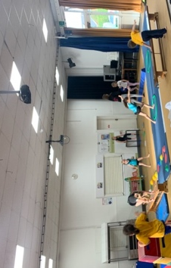
Flick and The Flexi Flics Team


